**Alekhya Krishna Balivada SQL Day 5 Assessment-5(08-12-2023)**

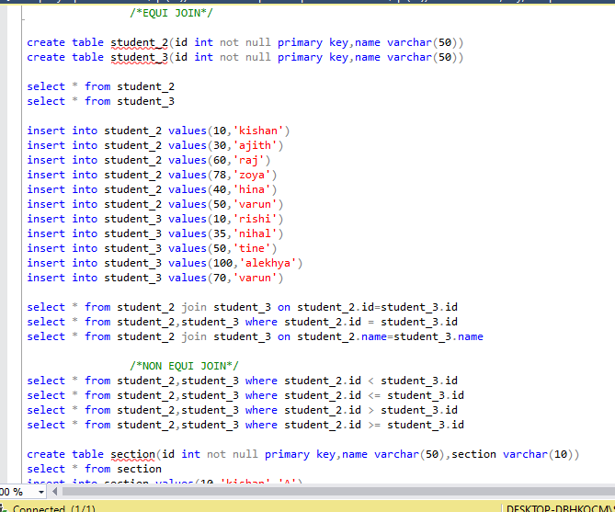**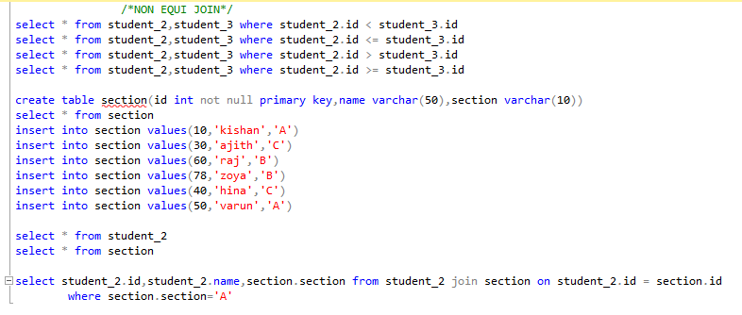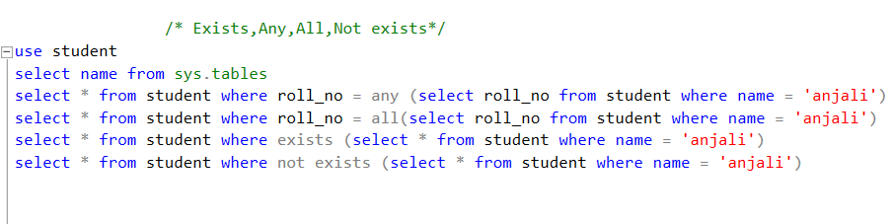Equi Join** **Non Equi Join**

**Exists, Any, All, Non Exists operations**

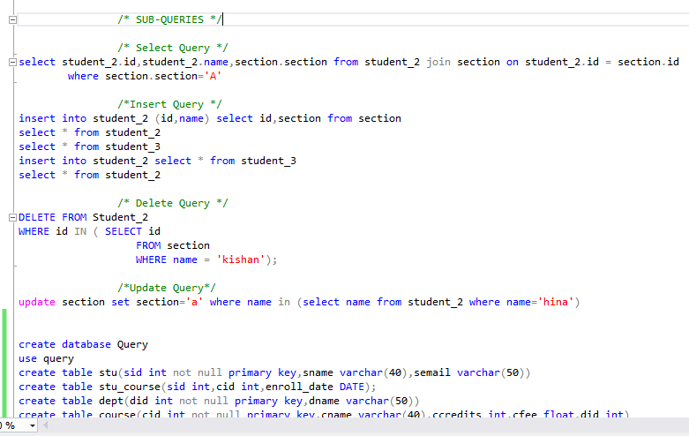

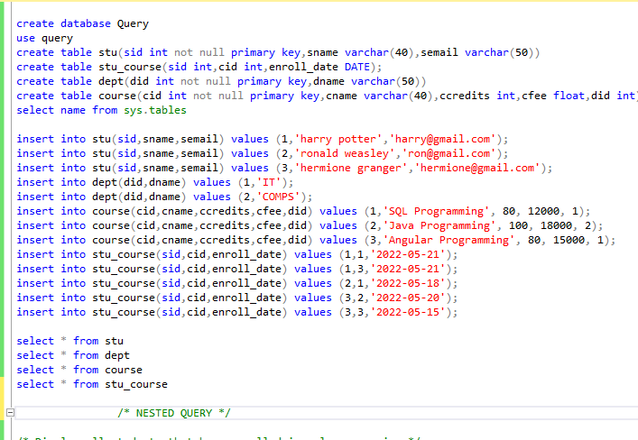Sub Queries using select, insert, update and delete

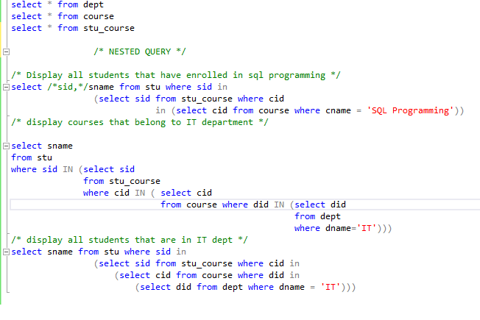Database creation for nested query

Nested Query Execution